# [Neal Baer Reflects on Robin Williams’ LAW & ORDER: SPECIAL VICTIMS UNIT Guest Spot](https://www.givememyremote.com/remote/2019/09/20/authority-robin-williams-svu-neal-baer/)

September 20, 2019 by [Marisa Roffman](https://www.givememyremote.com/remote/author/marisa/)

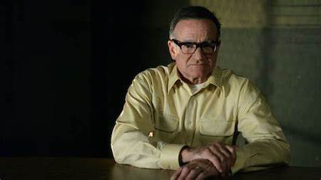

***LAW & ORDER: SPECIAL VICTIMS UNIT– “Authority” Episode 90017 — Airdate 04/29/2008 — Pictured: Robin Williams as Merritt Rook — NBC Photo: Virginia Sherwood***

When LAW & ORDER: SPECIAL VICTIMS UNIT celebrated its 200th episode, “Authority,” in 2008, the show recruited a big guest star: Robin Williams.

Williams portrayed Merritt Rook, a man who pretended to be a police officer over the phone and prompted people to commit crimes.

“There was a [real] guy who was calling people at fast food restaurants, telling them to strip search women cashiers and they would do it,” Neal Baer, who co-wrote “Authority,” says. “But I have to make Robin somewhat redeemable so he also had a really, really bad family life and bad things happened to his family.”

In the hour, Rook escalated and kidnapped Olivia (Mariska Hargitay)…and performed the [Milgram experiment](https://en.wikipedia.org/wiki/Milgram_experiment)—faking her torture—to see what Elliot (Chris Meloni) would do to save her.

“I like stories about authority, and going against authority,” Baer says. “And what would Stabler do to save her? [But Rook] really didn’t harm Olivia. And he disappeared [at the end]. And who knows where that character is now?”

Baer acknowledges that he “would have loved” to bring Williams back, but the “real life intervened.” But the experience filming with him was memorable. “A dear, lovely man,” he recalls. “When the director would yell cut, Robin would continue with his character and we would laugh our heads off.”